Week 2 –ETL Process of Master Table (Team Report)

Internship: Data Visualization Associate (Excelerate Virtual Internship)
Week: 2 – Master Table Creation, ETL Procedure & Data Quality Checks
Team Contribution: Joint report covering schema design, stored procedure development, and validation of the ETL process.

Introduction
During the first week of the Excelerate Data Visualization Internship, our team progressed from exploratory data analysis toward the integration and engineering phase.Then in 2nd week, the focus was on consolidating multiple raw datasets into a single structured Master Table, supported by an automated ETL procedure. This stage was crucial for ensuring data consistency, accuracy, and efficiency, laying a strong foundation for the advanced visualization and analytical work in the upcoming weeks.

Objectives
The objectives for this week included:
- Design and create the Master Table schema
- Define constraints, keys, and indexes to ensure performance and integrity
- Develop a stored procedure to automate extraction, transformation, and loading (ETL)
- Apply cleaning rules for duplicates, missing values, and inconsistent text formats
- Validate the process through quality checks and document findings in a Data Quality Report

List of Assigned Datasets

- User_data.csv
- Opportunity_Raw.csv
- Cohort_Raw.csv
- Marketing_data.csv
- Learner_Opportunity_Raw.xlsx
- Cognito_Raw2.xlsx

By the end of the week, the team successfully delivered a fully integrated Master Table, an ETL stored procedure that standardized and cleaned the raw inputs, and a Data Quality Report that documented issues detected, cleaning logic applied, and validation methods used. These deliverables ensure traceability, reproducibility, and high-quality data integration, establishing a solid groundwork for visualization and advanced analytics in the following stages of the internship.

Exploring All Datasets :

Dataset Name | Column Name | Role in Schema | Key Type
User_data.csv | learner_id | Unique identifier for learners | PK
 | country, degree, institution, major | Attributes linked to learner | —
Opportunity_Raw.csv | opportunity_id | Unique identifier for opportunities | PK
 | opportunity_name, category, opportunity_code, tracking_questions | Attributes linked to opportunity | —
Cohort_Raw.csv | cohort_id | Unique identifier for cohorts | PK
 | cohort_code | Links learners to cohorts | Alternate Key
Marketing_data.csv | campaign_name (or Ad Account Name)* | Identifiers for marketing campaigns (no direct link to Master Table) | PK (local only)
 | Other campaign attributes (reach, clicks, cost, etc.) | Analytics fields | —
Learner_Opportunity_Raw.csv | enrollment_id | Unique enrollment record | PK
 | learner_id | Connects to User_data.learner_id | FK → User_data(learner_id)
 | assigned_cohort | Connects to Cohort_Raw.cohort_code | FK → Cohort_Raw(cohort_code)
 | opportunity_id (from mapping) | Connects to Opportunity_Raw.opportunity_id | FK → Opportunity_Raw(opportunity_id)
 | status, apply_date | Enrollment metadata | —
Cognito_Raw2.csv | user_id | Unique identifier for authentication records | PK
 | learner_id (via mapping in Master Table) | Links Cognito users with learners | FK → User_data(learner_id)
 | email, gender, birthdate, city, zip, state, usercreatedate, userlastmodifieddate | Attributes | —

Schema Diagram:

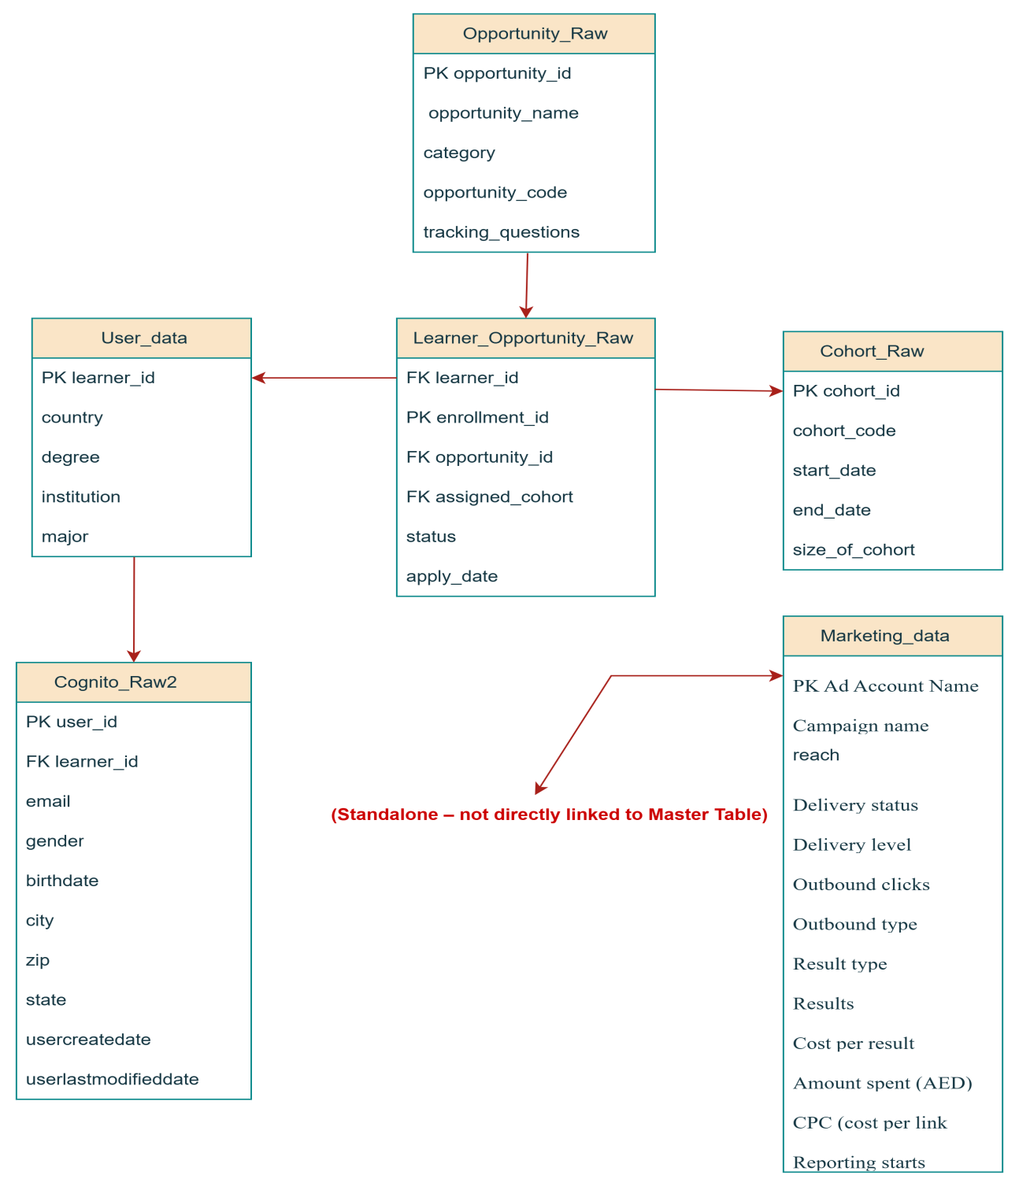

Planning of Master Table:
Column Name | Source Dataset(s) | Reason for Inclusion
enrollment_id (PK) | Generated during ETL | A new, unique ID created for each row; ensures that every application by a learner to an opportunity is uniquely identified for accurate analysis and management.
learner_id (FK) | Learner_Raw, Cognito_Raw2 | Unique student identifier; connects demographic info (Cognito) with academic background (Learner) and actions (LearnerOpportunity).
opportunity_id (FK) | Opportunity_Raw, LearnerOpportunity_Raw | Identifies the specific opportunity a learner applied for; links to details like name and category to analyze popularity and relevance.
cohort_id (FK) | Cohort_Raw, LearnerOpportunity_Raw | Identifies the cohort associated with an application; connects learners to timelines with cohort start/end dates.
email | Cognito_Raw2 | Provides essential contact info and acts as a human-readable learner identifier.
gender | Cognito_Raw2 | Basic demographic info for segmentation and trend analysis across genders.
birthdate | Cognito_Raw2 | Enables age-based analysis, such as age distribution of applicants.
city, state, country | Cognito_Raw2, Learner_Raw | Key geographic data for analyzing regional trends, target markets, and distribution of learners.
degree, institution, major | Learner_Raw | Academic background details; useful for analyzing correlations between education and opportunity success.
opportunity_name, opportunity_category | Opportunity_Raw | Adds descriptive context to opportunity_id; improves readability of reports and analysis.
cohort_start_date, cohort_end_date | Cohort_Raw | Provides program timeline; essential for planning, tracking, and analyzing program duration.
apply_date | LearnerOpportunity_Raw | Exact timestamp of application; critical for time-series analysis and tracking trends.
status | LearnerOpportunity_Raw | Shows application outcome (e.g., Accepted, Rejected, In Progress); key metric for program and learner success.

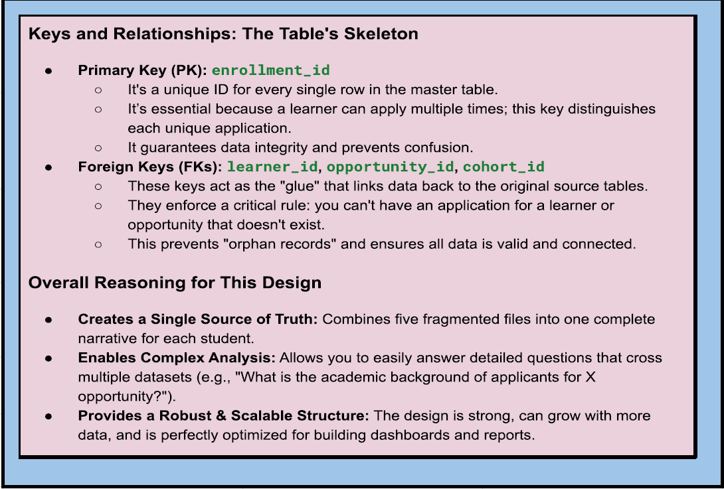

Master Table Creation:
Query:

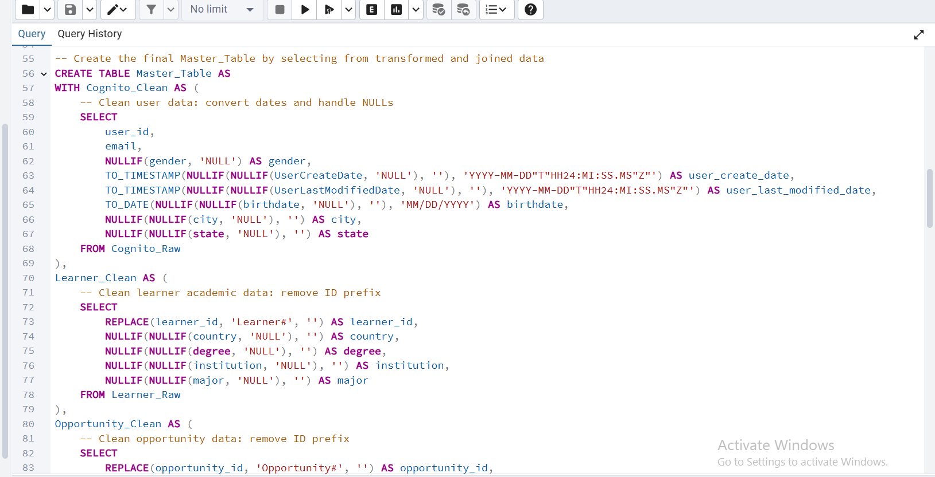
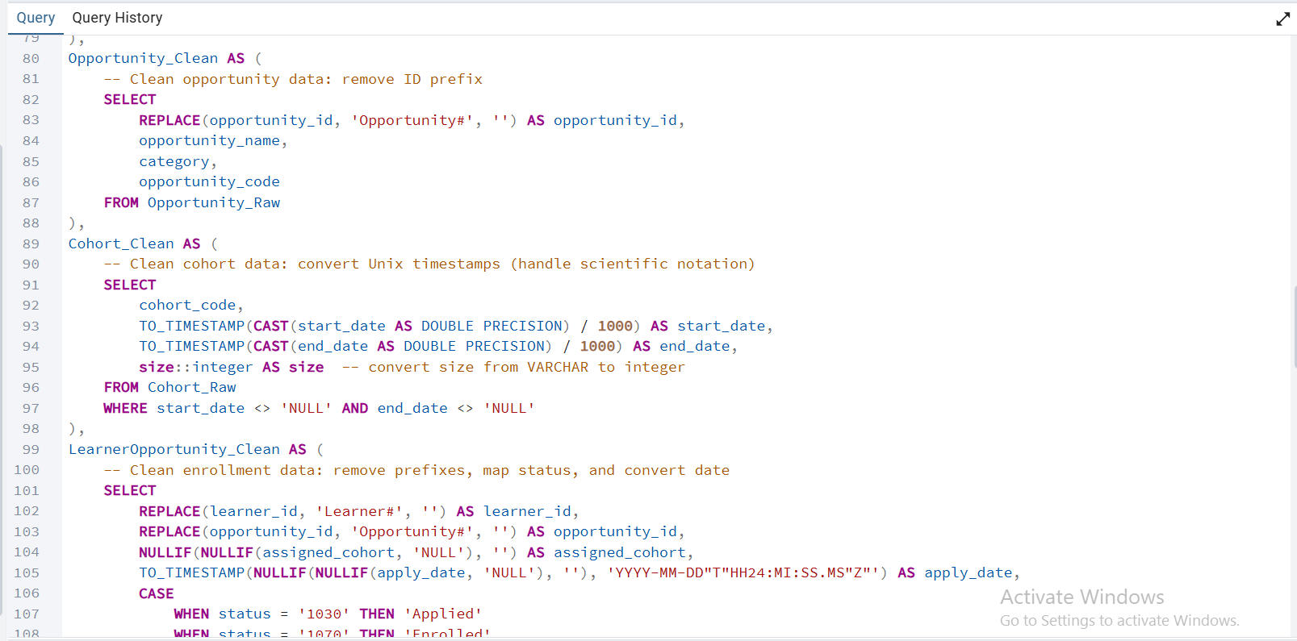
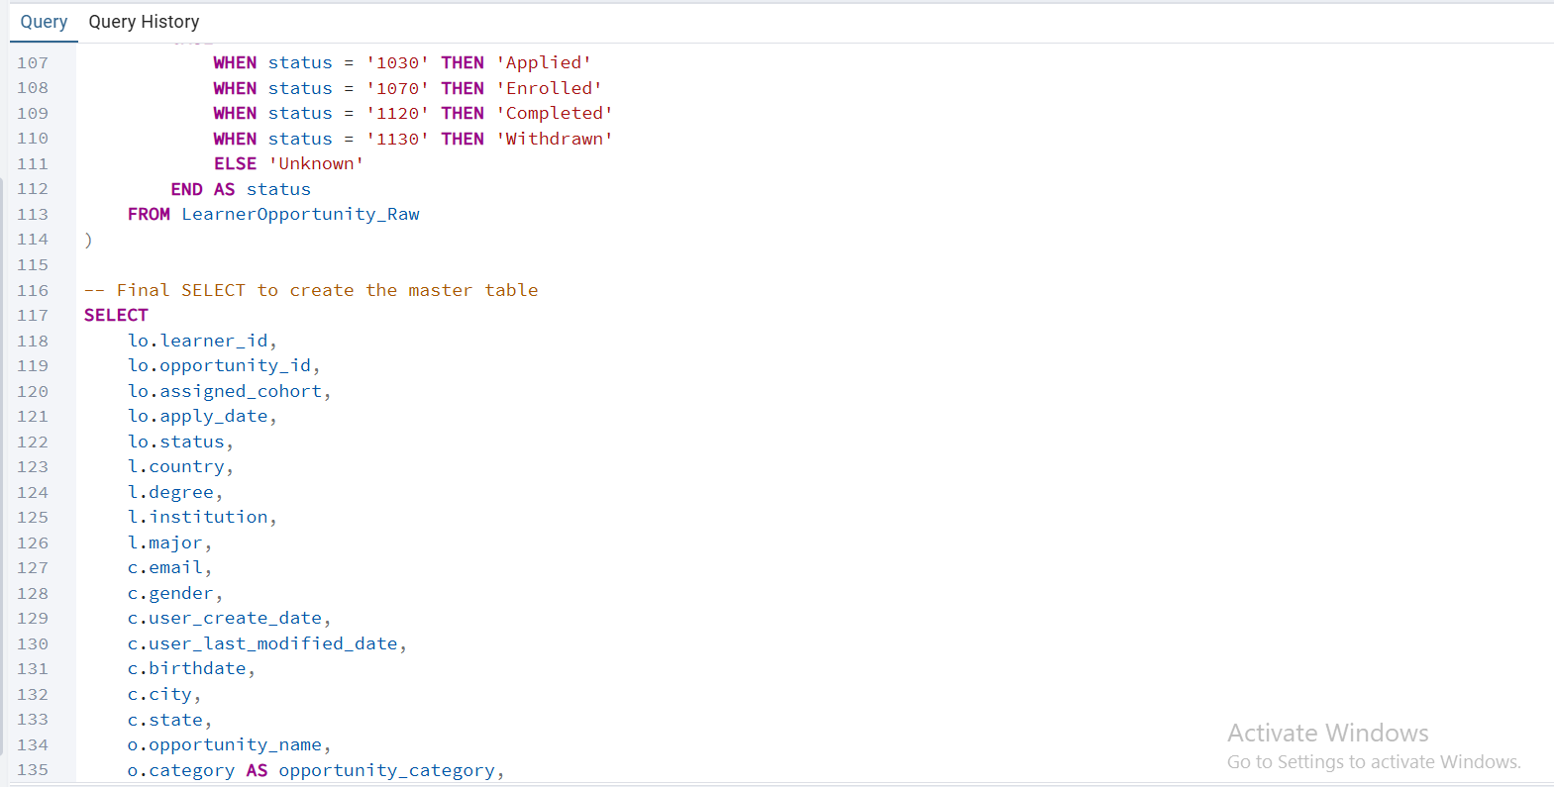
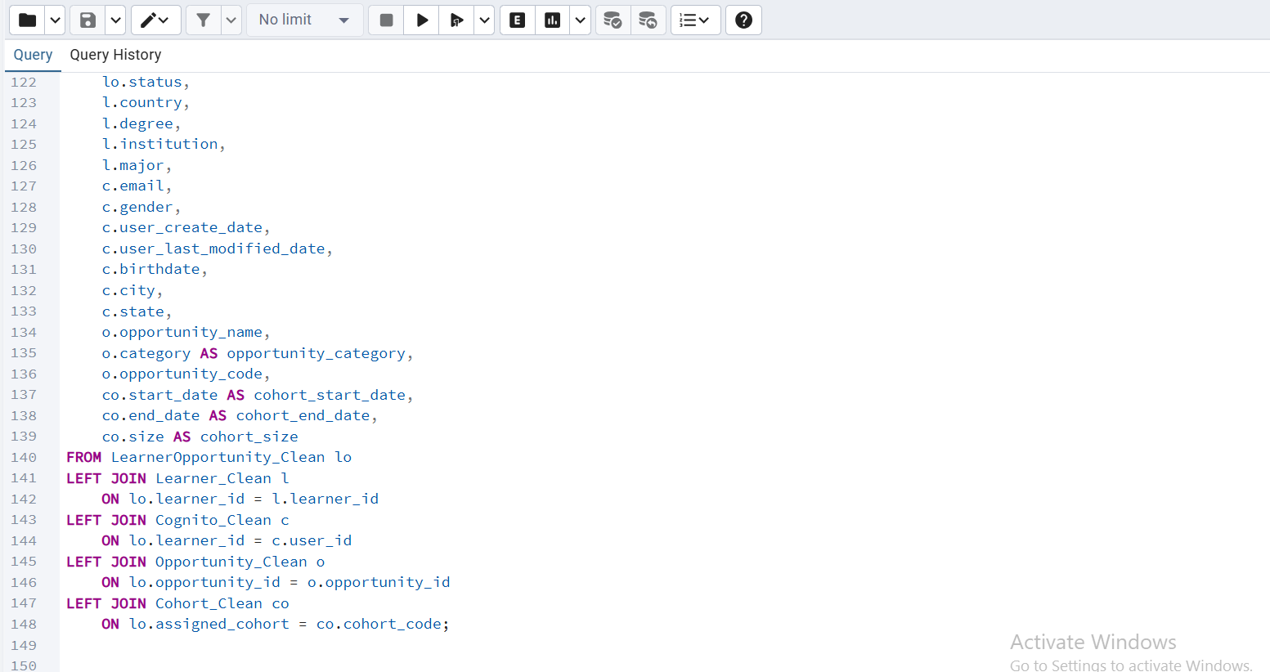

Output:
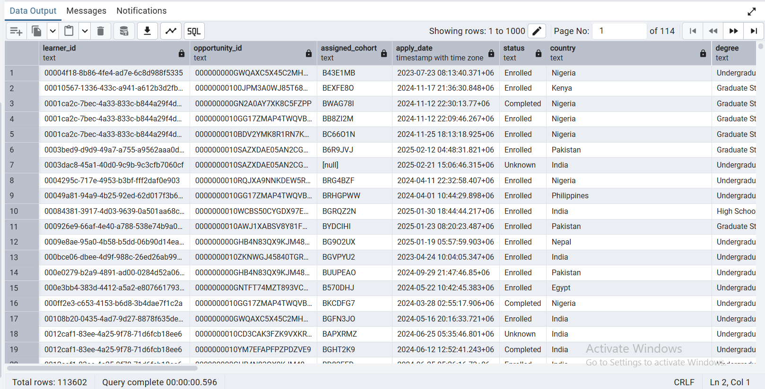

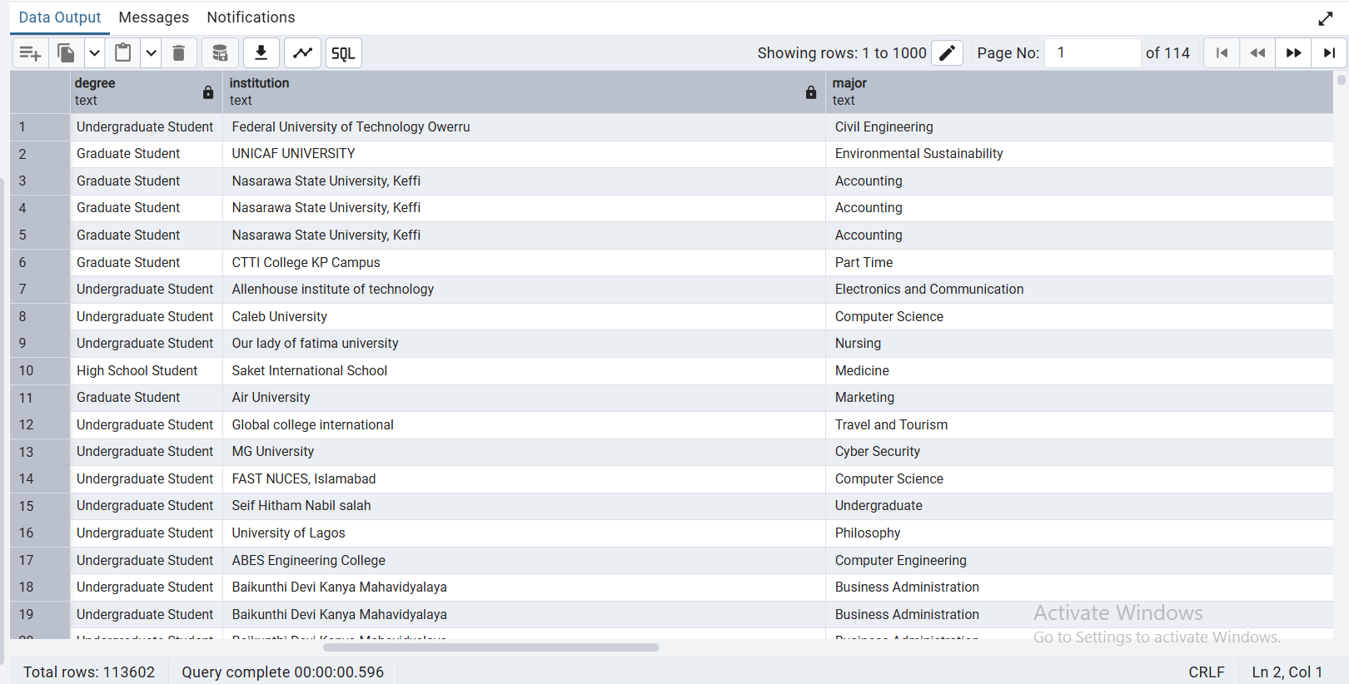

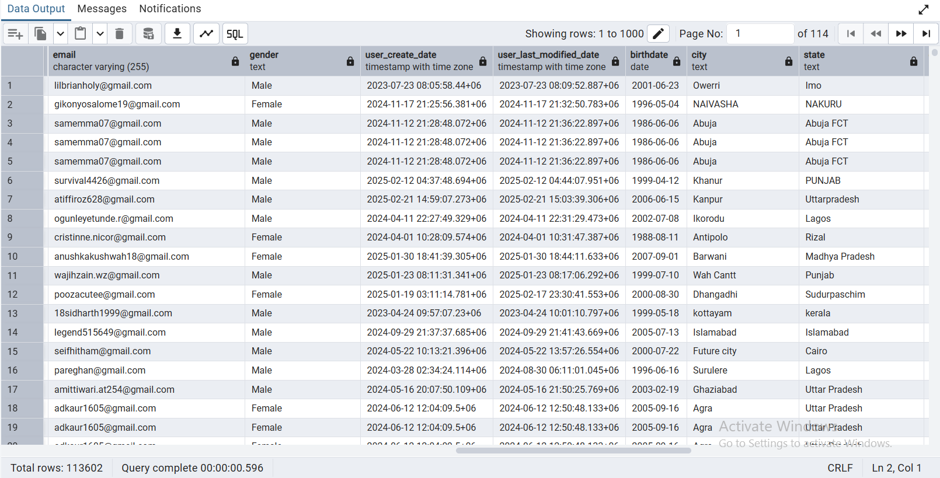

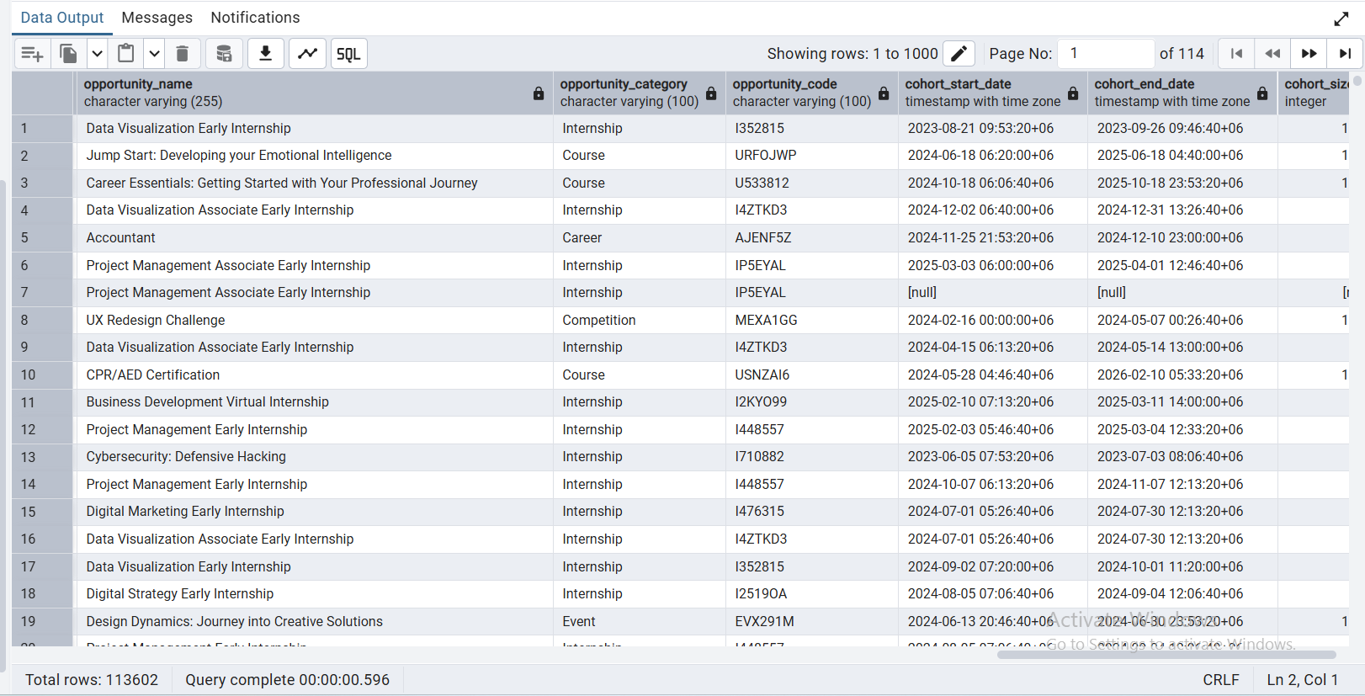
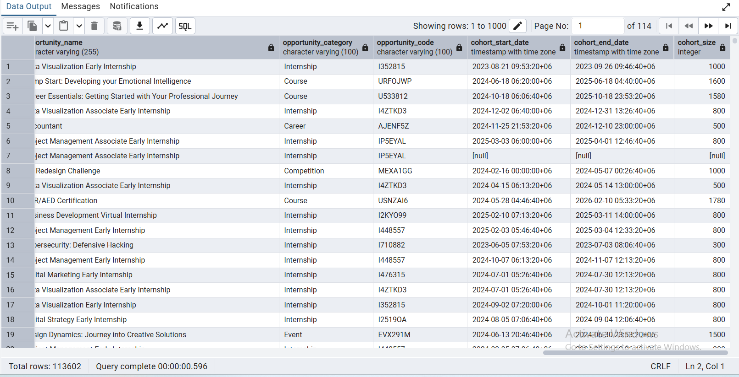

ETL Process (Extract, Transform & Load) Of Master Table:

Data Cleaning :

Correction of datatypes in each column in master_table:
Query:
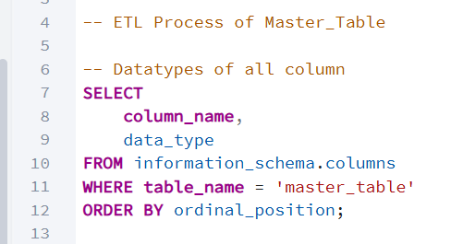

Output:
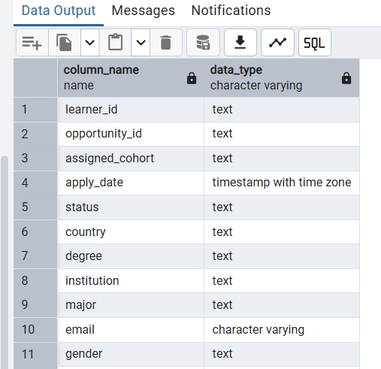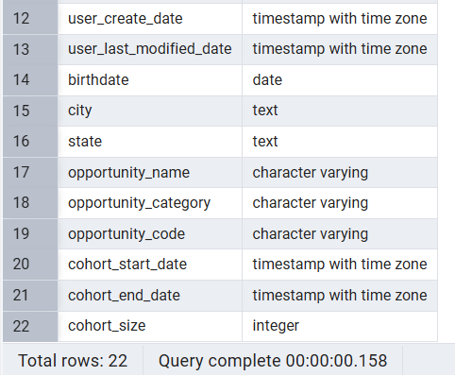

Checking if there is actual null/missing values in each column:
Query: (for checking null counts)
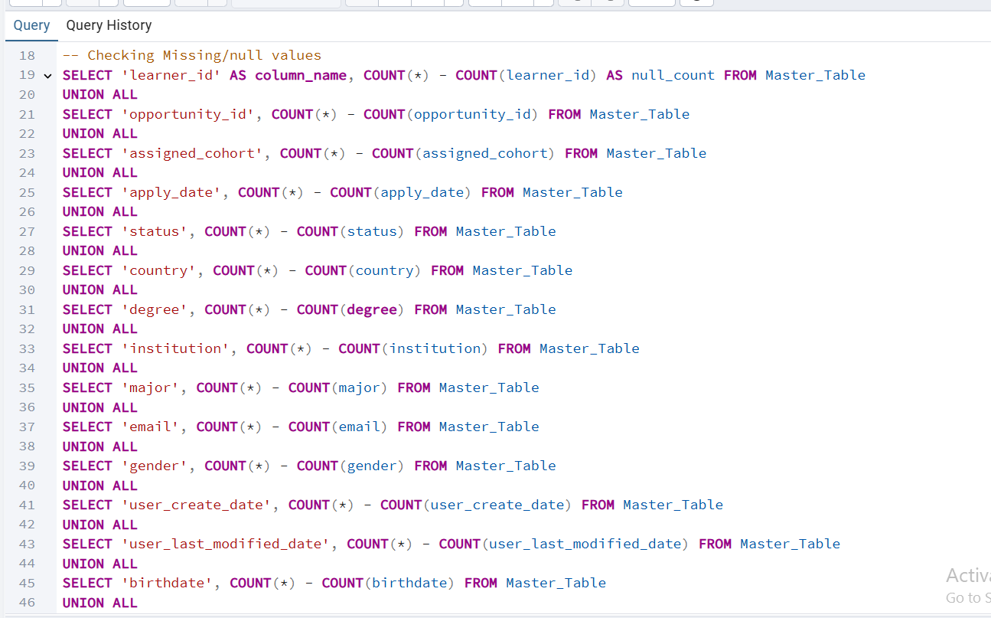
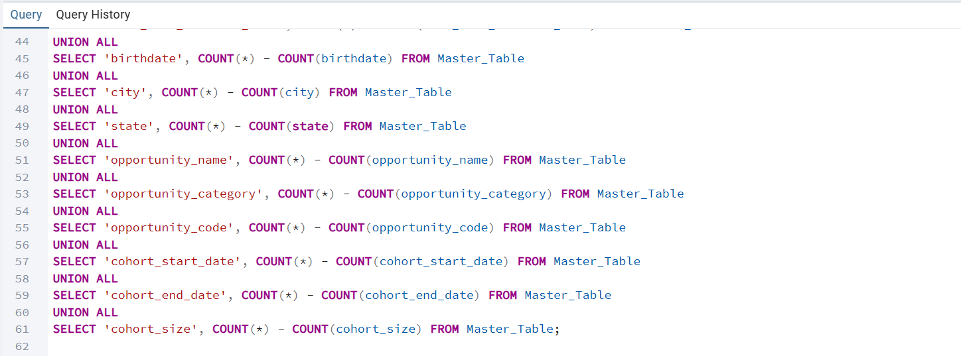
Output:
Before
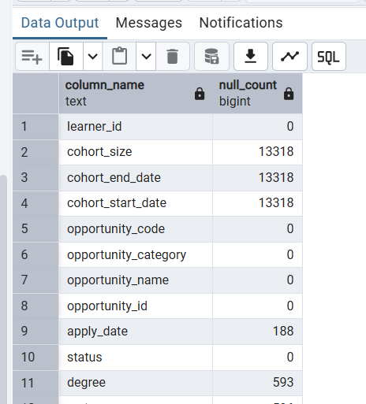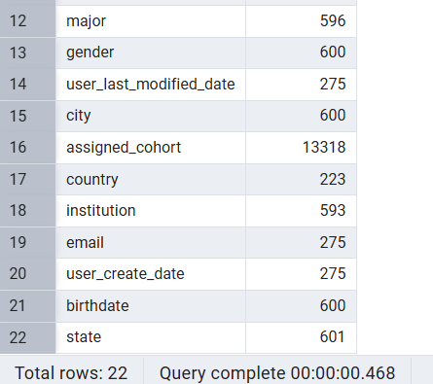

VS After (cleaning)

Query: (for removing nulls & replacing valid values)
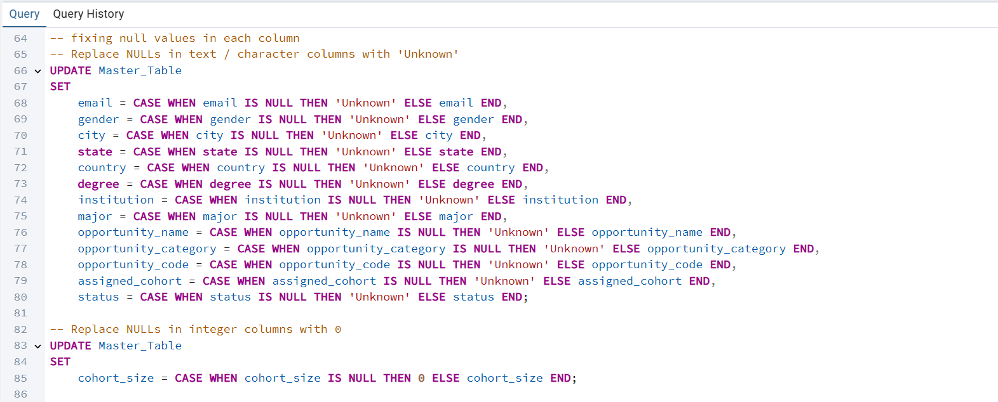
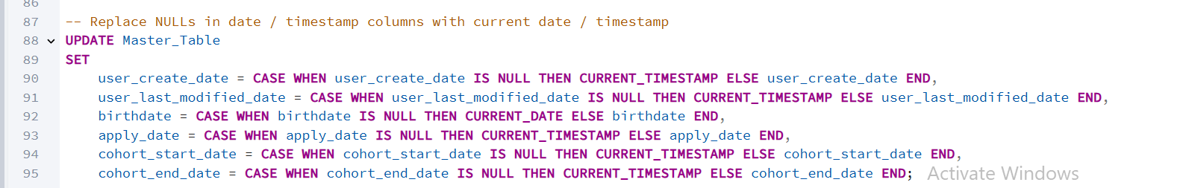
Output:

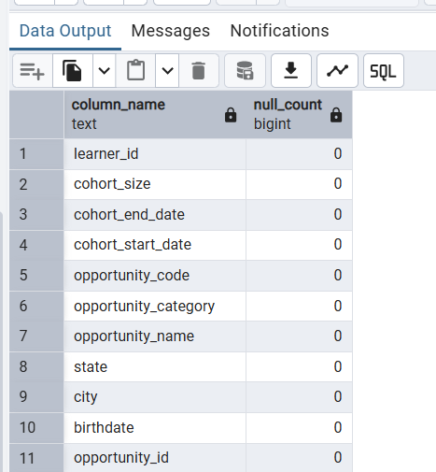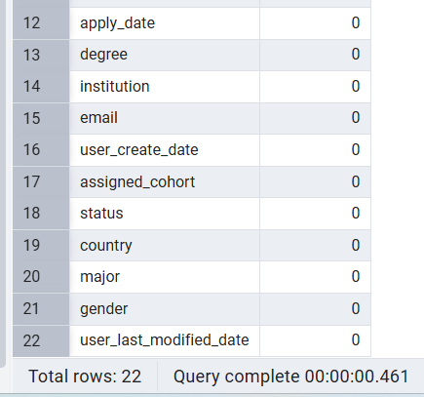

Checking if there is text type “NULL” values in each column:
Query: (for checking NULL text type values )

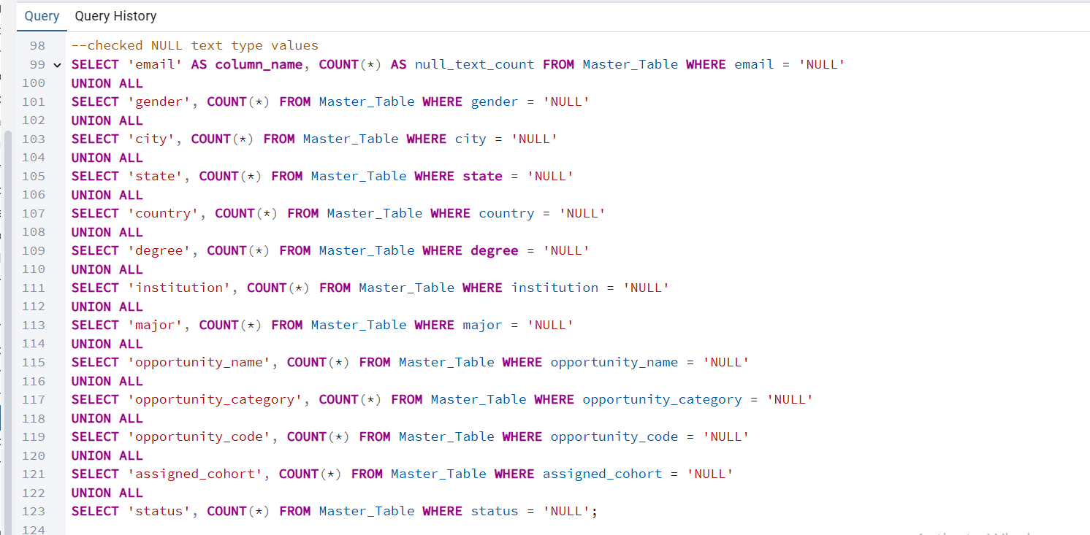

Output:

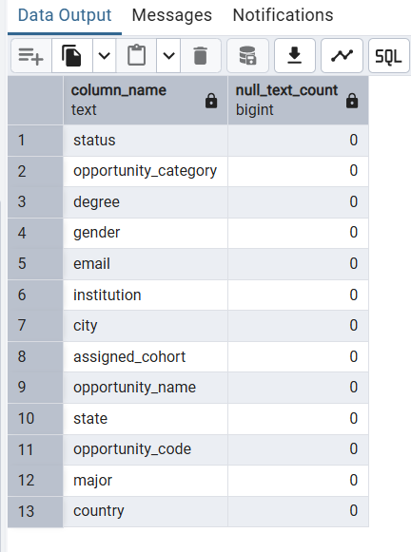

Checked if there is any duplicate records and Total Records:
Query:
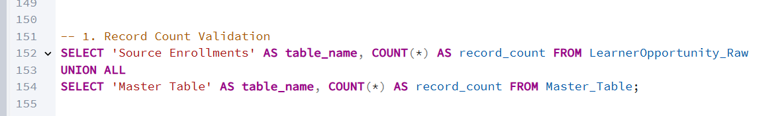
Output:

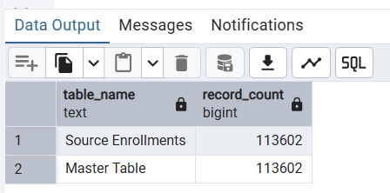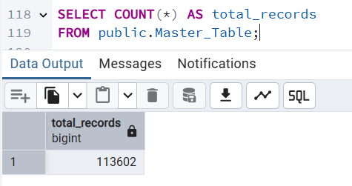
As Source Enrollments Records =Master table Records, there is no duplicate records in Master_Table.

Checking & Removing URLs (Don%27t want to specify) values from “gender” column:
Query:
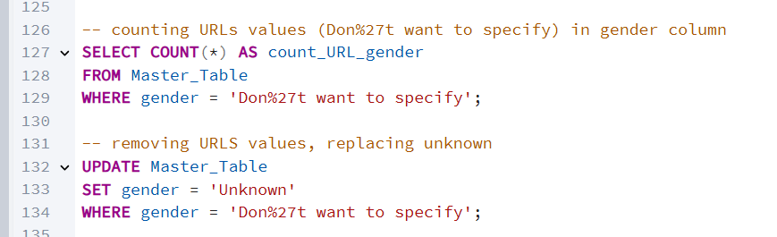
Output:
Before VS After (cleaning)
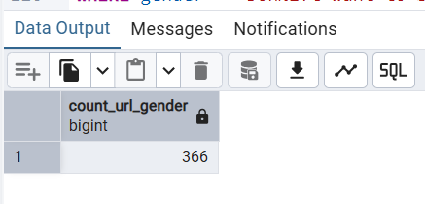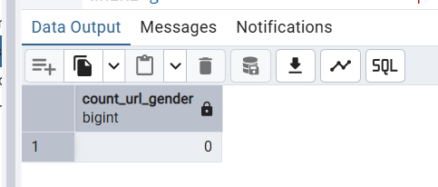

Final Master Table After Data Cleaning (Viewing first 15 rows )

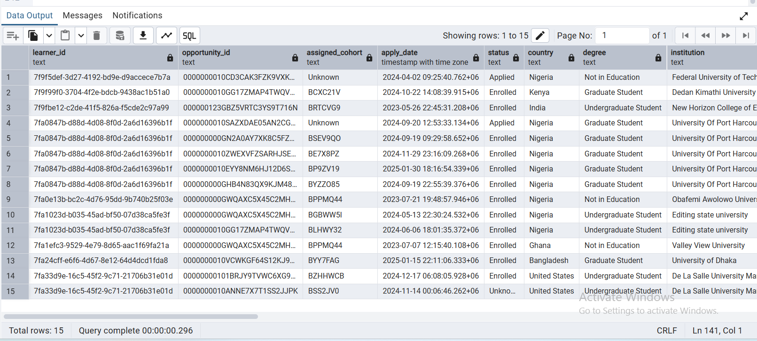

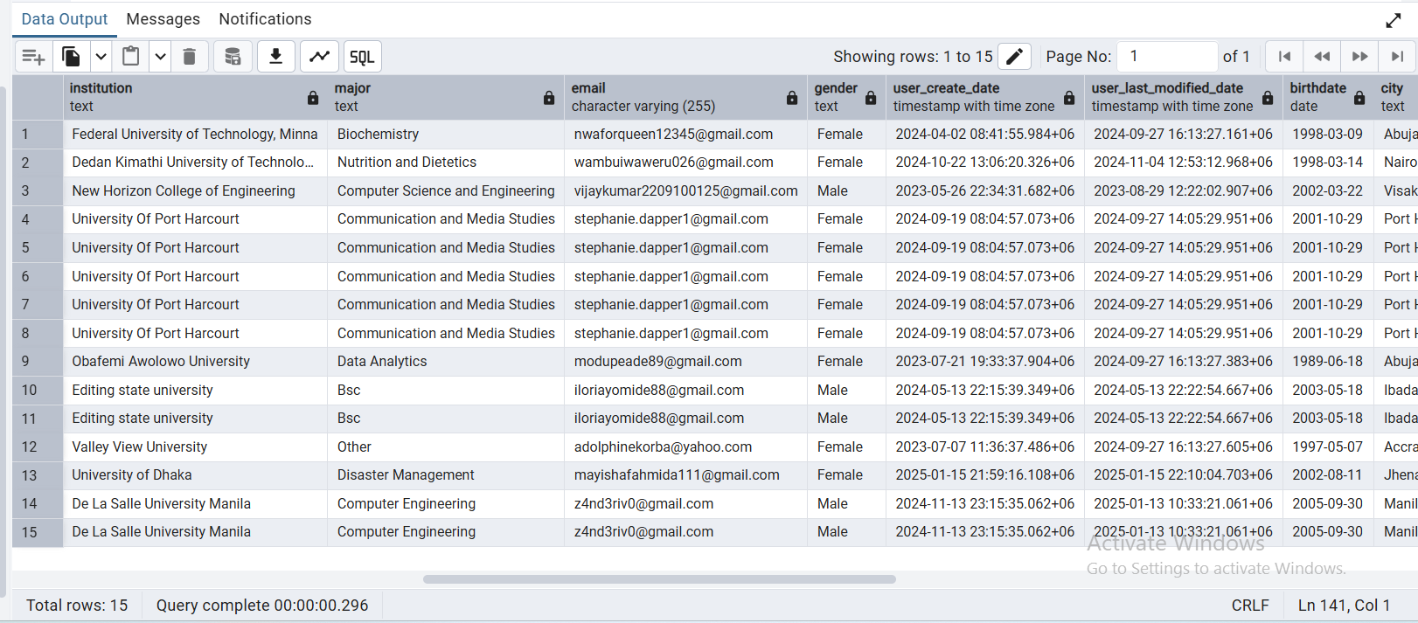

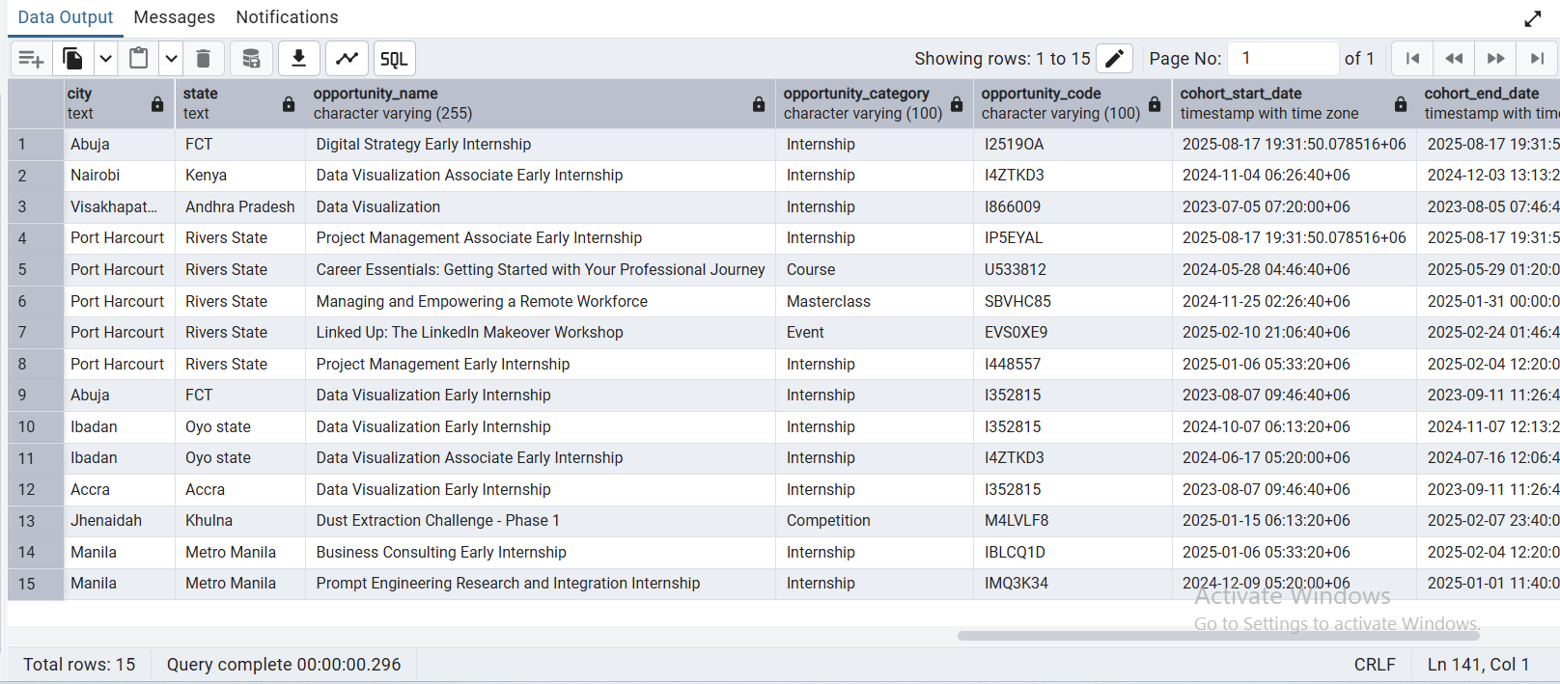
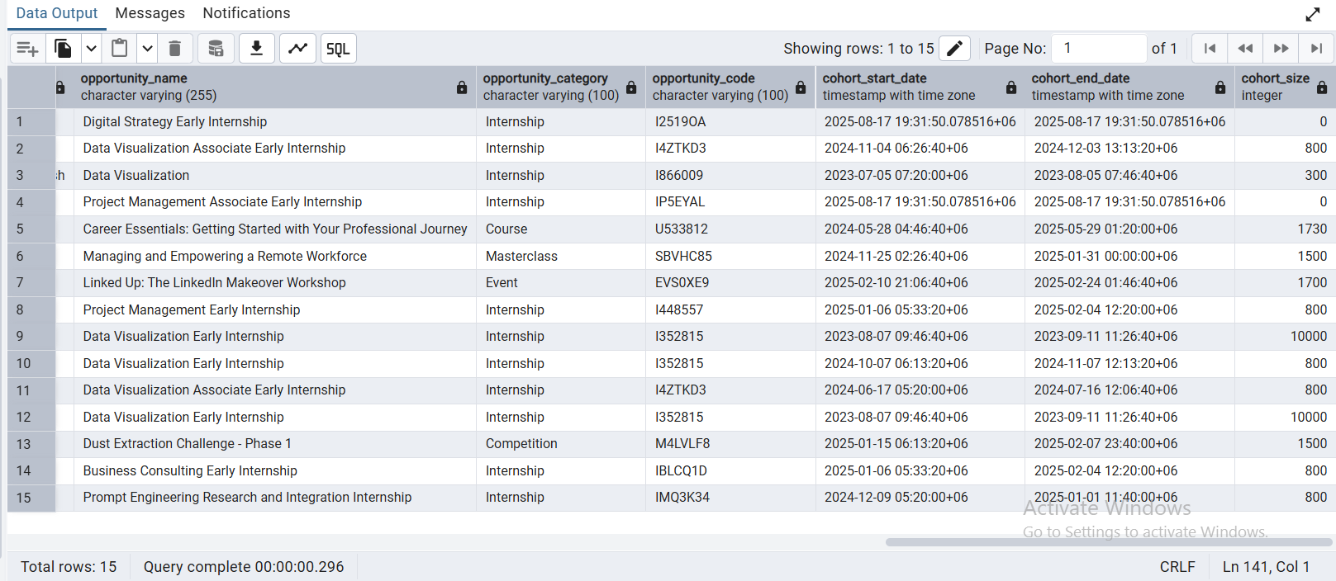

Summary of Data Quality After ETL process of Master Table:

Issues Detected | Cleaning Logic Applied | Testing Methodology
Datatype inconsistencies | Converted all columns to correct datatype:  • TEXT for IDs and textual fields  • INTEGER for numeric fields (cohort_size)  • DATE for birthdate, cohort_start_date, cohort_end_date  • TIMESTAMP WITH TIME ZONE for apply_date, user_create_date, user_last_modified_date | Verified schema using Master_Table; tested date arithmetic and numeric operations; spot-checked ID columns remain as TEXT
Missing / NULL values in TEXT columns | Replaced literal "NULL" text and SQL NULLs with 'Unknown' | Counted NULL / 'NULL' values before and after cleaning for each column; confirmed replacements
Missing / NULL values in numeric columns | Replaced NULLs with 0 | Counted NULL values before and after; verified totals remain consistent
Missing / NULL values in DATE / TIMESTAMP columns | Replaced NULLs with current date / timestamp | Counted NULL values before and after; spot-checked sample records to confirm updated timestamps
Gender column containing placeholder text | Replaced entries like "Don%27t want to specify" with 'Unknown' | Spot-checked gender column; counted occurrences before and after replacement
Null / missing join keys | Ensured join keys exist for relationships | Tested joins with Learner_Raw, Cognito_Raw, Opportunity_Raw, Cohort_Raw; confirmed no missing matches

Conclusion:
In Week 2, the team focused on creating the Master Table and implementing the ETL process. All raw datasets were integrated into a single structured table, ensuring proper relationships through primary and foreign keys. The ETL procedure standardized text fields, handled NULLs and placeholder values, removed duplicates, and converted dates and status codes into consistent formats. These steps ensured that the Master Table is clean, reliable, and ready for analysis. The resulting Master Table serves as a robust, standardized dataset, forming the backbone for all subsequent data visualization, reporting, and analytical tasks, with no remaining inconsistencies, missing values, or unreliable entries.

